Andrew Dykman – Business Concepts for Application Developers – Lab 2 – 7/17/2012

Task 1.1) Research done as required and cited Chicago Manual of Style in Task 1.4

Task 1.2)

Assumed Management Structure of Amazon.com using Visio 2010 (Screencapture)

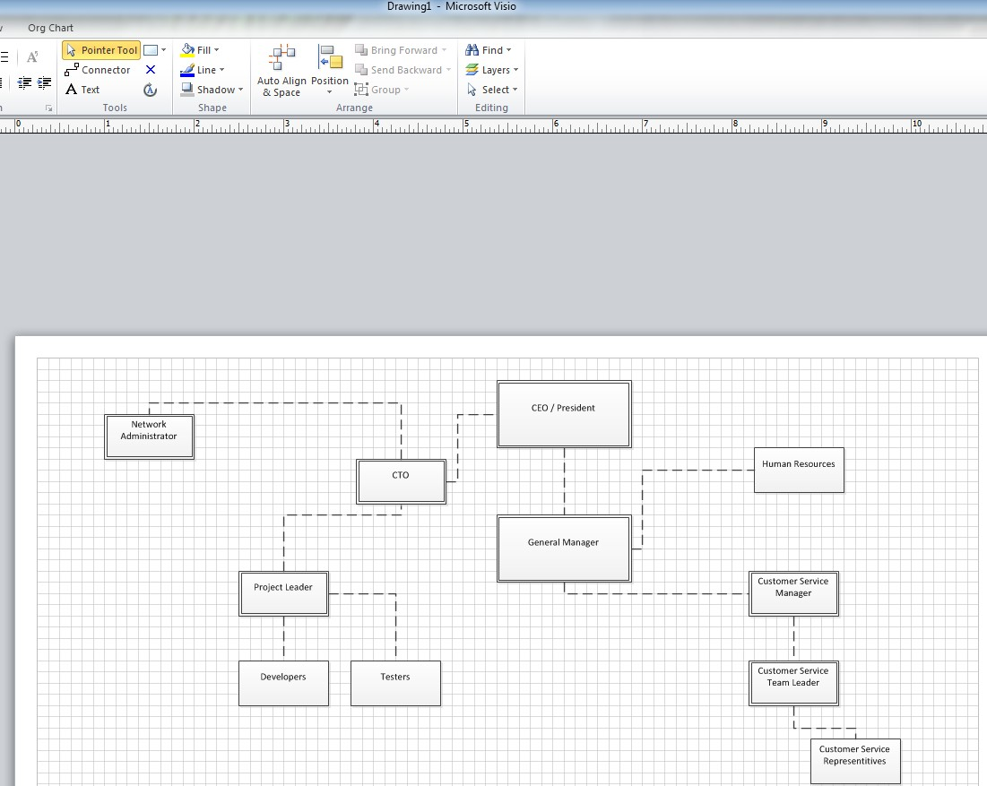

Task 1.3)

a.) Amazon would seem like it would have a bureaucratic organizational structure, but as a matter of fact I know it has a special organizational structure used by internet companies called a Virtual Structure. The virtual organization exists within a network of alliances, using the internet.

b.) As mentioned above, the structure which *seems* like a organizational structure that could apply to Amazon.com is the bureaucratic structure, as this is a common structure used within all larger scale companies, but because of the unique nature of the fact that their main presence is on the internet, and the partnership it has with other companies it is indeed a Virtual Structure and not a bureaucratic one.

Task 1.4)

Vogelstein, Fred. ”Mighty Amazon Jeff Bezos has been hailed as a visionary and put down as a goofball. He's proved critics wrong by forging a winning management strategy built on brains, guts, and above all, numbers.” CNN Money. 26 May 2006. http://money.cnn.com/magazines/fortune/fortune_archive/2003/05/26/343082/index.htm , (accessed July 16, 2012;).

Task 2.1)

a.) Autocratic: The C.E.O. Is required to make an executive decision on whether or not he will step down from management.
b.) Laissez-faire: A new intern at the company must learn from a seasoned developer
c.) Democratic: The company board, under pressure from the company employees as a whole reach a joint decision to merge with Microsoft
d.) The company C.E.O. Grants all employees the ability to manage themselves and persue their own coding goals one day a week as long as they don't conflict with the company's policies or vision statement. Anything software they produce during this time is property of the company.

Task 2.2) I would use the democratic style of management, because I believe as a whole people have the right idea of how things should be run, and also because I believe it increases employee morale and productivity as a whole when the employees feel that their voice and role in the company matters.

